**1.react core concepts**

Virtual DOM ?

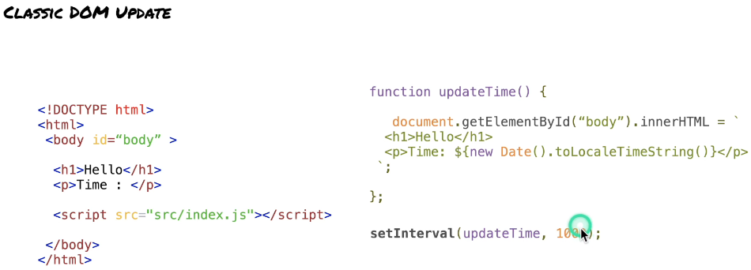 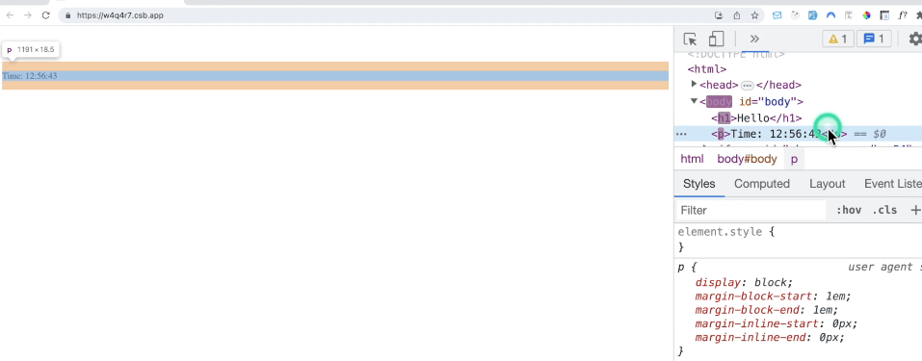

dom here while inspecting the code you'll see that basically the whole body is being updated every second. we are updating the body tag the h1 tag and the paragraph here. we don't really want to update everything. we just want to update this very

specific part.

so the natural behavior of JavaScript and the dom is to update all the children when you're updating a tag which is not really the most performant approach.

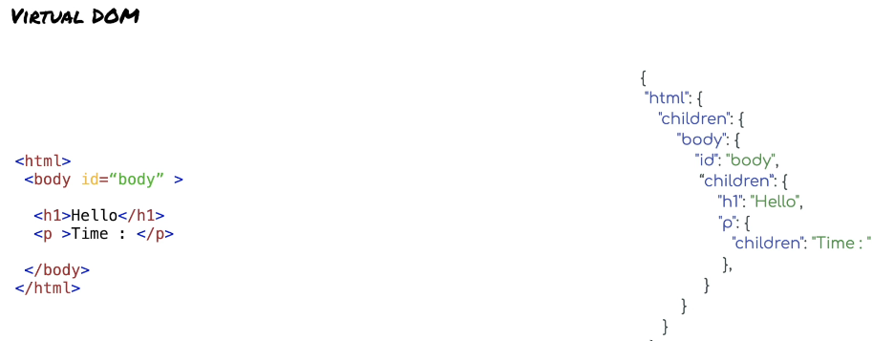

so the virtual dom is basically a lighter replica of the dom that I just shown you so the HTML tags, but it will it will take the form of an object you can imagine a JavaScript object for example and be careful okay a lot of people tend to think

that the virtual dom is faster no it's not faster because behind the scene it's using a regular dom okay it's just that it's going to be smarter and so it will sometimes improved performances.

